I give permission for my child to receive medical treatment from a qualified first aider if needed.
I enclose a cheque made payable to Jill Eccleston, 4 Prospect Terrace, Settle, BD24 9BL
I will pay by BACS 404031/41054120 child’s name as ref
Photographic consent Yes No
Please indicate which days attending: 28 29 30
Children need to come already changed in sports kit and need to bring a packed lunch, snacks and a water bottle. Shin pads (if they have them), spare trainers, boots, and warm clothes, waterproofs. They will need a bike in good working order and a helmet.
Children will only be supervised during the stated times. We cannot accept responsibility for loss of money or belongings, damage or injury arising from the courses.
Please complete and return this form to Jill by AUGUST 24TH & BACS payment to confirm your place ASAP info@runbikefun.co.uk 07955 342344

Application Form

Name:…………………………………….Ethnicity…………………………………………. Address:………………………………………………………………………………………………
Postcode……………...Date of Birth………………………….. Age ………………
Any medical conditions……………………………………………
Emergency contact details …………………………………………………………………………………

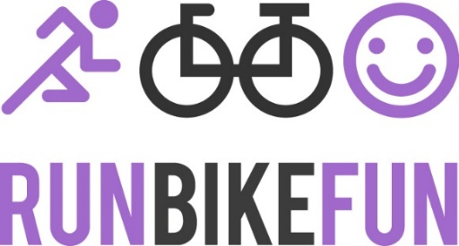
FOOTCYCLE FUN THIS SUMMER AT QUEEN ELIZABETHS SCHOOL
What could be more fun a combination of Football and Cycling organised by local British Cycling and England Athletics coach Jill Eccleston qualified to BC Level 2 and EA level 3 and Football coach Craig Perkins qualified to FA level 1 both with enhanced CRB checks and each a qualified first aider.
With lots of fun, games, skills, competitions and activities to promote physical literacy – Agility – Balance – Co-ordination = FUNDAMENTALS!
Ages 5-14 for boys and girls of all abilities.
The course will run for 3 days Tuesday 28, Wednesday 29, Thurs 30 August 9-3pm, at Queen Elizabeth School, Kirkby Lonsdale, Carnforth, Lancashire, LA6 2HJ

The courses are well structured with the players supervised at all times. We aim to develop children’s self-confidence, self-esteem through encouragement and positive reinforcement.
Cost per day £30 or £80 for 3 days with a 10% discount for siblings

